1. Greater Z-index on top of the stack.
2. Four types of advanced positioning:

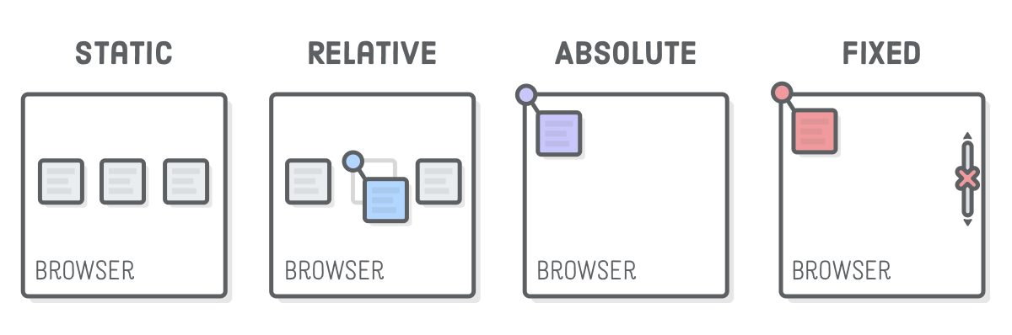

1. Three types of display:

